Category 1: Volumes & High-Level Rankings

1. Total Complaints Count
SELECT COUNT(*) AS [Grand Total of Complaints]
FROM Clean_Customer_Complains ;
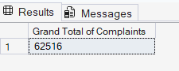
2. The Worst Financial Products
SELECT [Product], COUNT(*) AS [Total Complaints]
FROM Clean_Customer_Complains
GROUP BY [Product]
ORDER BY [Total Complaints] DESC;
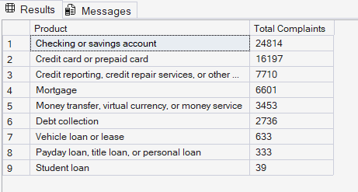
3. Top 10 Sub-Products
SELECT TOP 10 [Sub_product], COUNT(*) AS [Total Complaints]
FROM Clean_Customer_Complains
GROUP BY [Sub_product]
ORDER BY [Total Complaints] DESC;
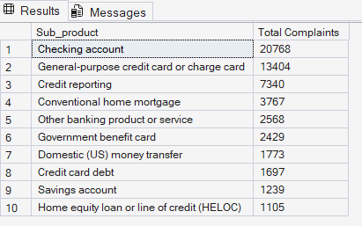
4. The Top 10 States for Disputes
SELECT TOP 10 [State], COUNT(*) AS [Total Complaints]
FROM Clean_Customer_Complains
GROUP BY [State]
ORDER BY [Total Complaints] DESC;
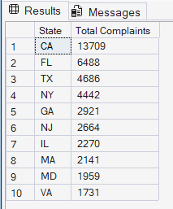

Category 2: Analyzing the Issues

5. Most Common Core Issues
SELECT TOP 10 [Issue], COUNT(*) AS [Frequency]
FROM Clean_Customer_Complains
GROUP BY [Issue]
ORDER BY [Frequency] DESC;
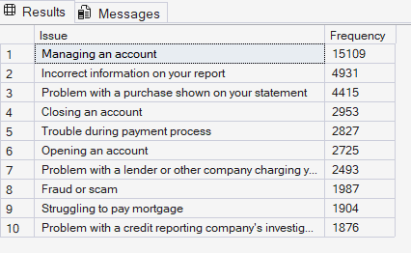
6. Top 10 Most Specific Sub-Issues
SELECT TOP 10 [Sub_issue], COUNT(*) AS [Frequency]
FROM Clean_Customer_Complains
GROUP BY [Sub_issue]
ORDER BY [Frequency] DESC;
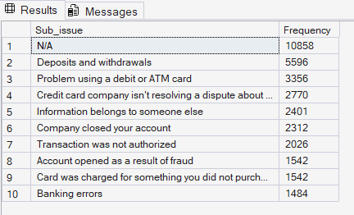
7. Specific Pain Points within Checking Accounts
SELECT TOP 10 [Issue], COUNT(*) AS [Total]
FROM Clean_Customer_Complains
WHERE [Product] = 'Checking or savings account'
GROUP BY [Issue]
ORDER BY [Total] DESC;
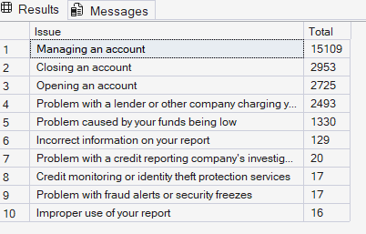
8. Specific Pain Points for Credit Cards
SELECT TOP 10 [Issue], COUNT(*) AS [Total]
FROM Clean_Customer_Complains
WHERE [Product] = 'Credit card or prepaid card'
GROUP BY [Issue]
ORDER BY [Total] DESC;
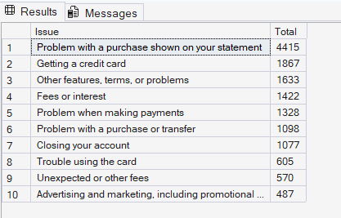

Category 3: Submission Channels & Company Responses

9. Breakdown of Submission Methods
SELECT [Submitted_via], COUNT(*) AS [Usage Count]
FROM Clean_Customer_Complains
GROUP BY [Submitted_via]
ORDER BY [Usage Count] DESC;
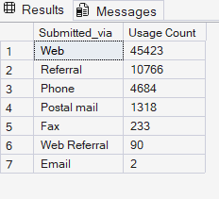
10. Ultimate Resolutions for Consumers
SELECT [Company_response_to_consumer], COUNT(*) AS [Total]
FROM Clean_Customer_Complains
GROUP BY [Company_response_to_consumer]
ORDER BY [Total] DESC;
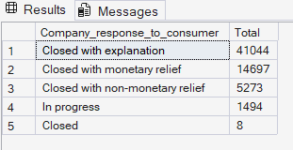
11. Count of Timely vs. Late Answers
SELECT [Timely_response], COUNT(*) AS [Total Complaints]
FROM Clean_Customer_Complains
GROUP BY [Timely_response];
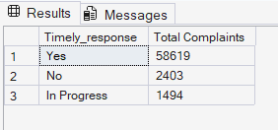
12. Corporate Transparency Rates
SELECT [Company_public_response], COUNT(*) AS [Count]
FROM Clean_Customer_Complains
GROUP BY [Company_public_response]
ORDER BY [Count] DESC;
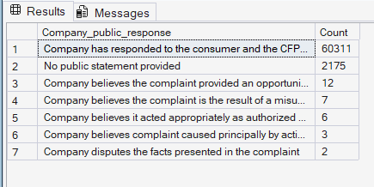
Category 4: Combined Target Filters

13. Complaints from New York Involving Monetary Relief
SELECT [Complaint_ID], [Product], [Issue]
FROM Clean_Customer_Complains
WHERE [State] = 'NY'
AND [Company_response_to_consumer] = 'Closed with monetary relief';
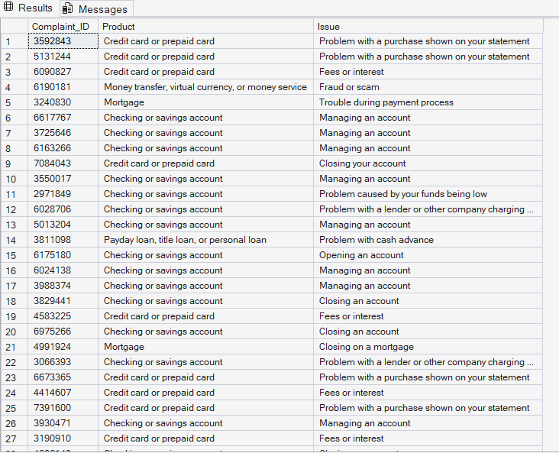

14. Untimely Responses on Mortgages
SELECT [Complaint_ID], [State], [Issue], [Company_response_to_consumer]
FROM Clean_Customer_Complains
WHERE [Product] = 'Mortgage'
AND [Timely_response] = 'No';
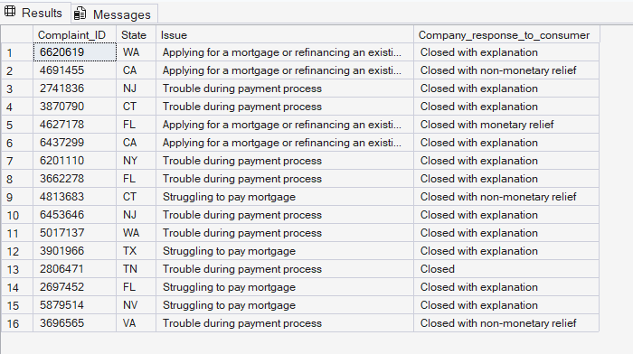
15. Active Ongoing Complaints ("In Progress")
SELECT [Complaint_ID], [State], [Product], [Submitted via]
FROM Clean_Customer_Complains
WHERE [Company_response_to_consumer] = 'In progress';
